 COSC 2320
Name: _________________ Terminal #_

Programming Assignment 3 JAVA:
(100 points.)
(Due date found in the COSC 2320 BB Calendar!)

The programming assignment is to be turned in as a hardcopy to include the source code & screenshots of the input/output AND zipped in BB Assignment PROGRAMMING ASSIGNMENT 3 as “Programming Assignment 3.zip” in the first ten minutes of the due date class.
A data file will be given to you in class for Acceptance Testing.
Assume the name “Programming Assignment 3 Data.txt”.

The hardcopy must contain the following statement and must be signed by the student.

I the undersigned declare that the project material, which I now submit, is my own work. Any assistance received by way of borrowing from the work of others has been cited and acknowledged within the work. I make this declaration in the knowledge that a breach of the rules pertaining to project submission may carry serious consequences.

Signature

___________________
Hash Table - Chaining - Cell Phone Contact List Application
ProgrammingAssignment3 APPLICATION
OOA, OOD, and OO Implement in JAVA:

A cell phone manufacturer would like a Java program (Using MVC classes, design an ProgrammingAssignment3 APPLICATION) that maintains the list of contacts for a cell phone owner. For each contact, a person’s name, there should be a list of phone numbers that can be changed. The manufacturer desires an interface for the software (ContactListInterface and ContactList Class).

- addOrChangeEntry( String name, List< String> numbers)

Changes the numbers associated with the given name or adds a new entry with this name and list of numbers. Returns the old list of numbers or null if this is a new entry.

- lookupEntry( String name)

Searches the contact list for the given name and returns its list of numbers or null
if the name is not found.

- removeEntry( String name)

Removes the entry with the specified name from the contact list and returns its list of numbers or null if the name is not in the contact list.

- display();

Displays the contact list in order by name.

A hash table Class is an ideal data structure for the contact list. It will associate names (which are unique) to lists of phone numbers. Therefore, the name is a key field and the list of phone numbers “is” the value field.

Sample entries would be:

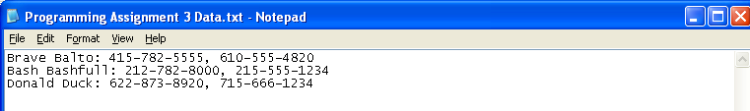

Create a ProgrammingAssignment3.java that contains the main method.

You cannot use any DATA STRUCTURES JCL classes! Use linked Nodes/Chaining.
One class per .java file!
Must use MVC Design Pattern.

Each .java file must have these 4 lines of comments (you will lose 5 points if not):
// COSC 2320 Spring 2014
// Name:
// Programming Assignment 3
// This is my own work; I will not post

http://cristobal.baray.com/indiana/projects/mvc.html

MVC Introduction
The main idea behind design patterns is to extract the high level interactions between objects and reuse their behaviors from application to application. They were inspired by an architect, Christopher Alexander, discussing the way that architectural design has patterns of its own:
Each pattern describes a problem which occurs over and over again in our environment, and then describes the core of the solution to that problem, in such a way that you can use this solution a million times over, without ever doing it the same way twice.
A Timeless Way of Building
In theory this sounds great, but I've found in practice it takes some getting used to. Admittedly, it might take longer for me cause I'm a (reforming?) guerrilla programmer (the error in my ways has caught up with me and I'm taking steps towards programming for people - not computers). Sure, I've found that the design patterns are useful, but their advantage is not only in creating re-usable, easy to understand code - but, more importantly in helping me clarify the way that I think about programs. I find this second advantage much more substantial.
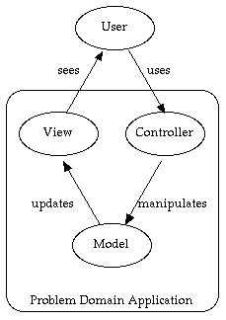
Writing code is usually the easy part - the hard part is figuring out exactly what code to write. Time spent carefully thinking about the code to write will save enormous amounts of time and effort when it comes to actually writing the code. Still, many people don't always work that way - myself included. Design patterns are helping me shape the way I parse a problem, which leads to helping me break up the problem into objects and modules. The Model View Controller pattern has probably changed my style and efficiency the most. It has lead to new ways of writing entire applications, constantly improving my applications in usability. Yet, while I was learning about the pattern, I was surprised at how hard it was to find information about it (some of the more useful bits of info I found are included in my references page - though Head First has become my favorite learning tool).
So, I decided to add a couple of pages about the pattern myself. I want to share some info about the pattern that I've found so useful but seems to get so little press. And I figured it would also clarify it even more in my own head. One little disclaimer - you might notice differences between what I present and what others present. The differences are representative of our styles I suppose - because I've made adjustments along the way and have changed things. I've tried to mention these areas when they pop up.
The MVC pattern is surprisingly simple, yet incredibly useful. Essentially, the pattern forces one to think of the application in terms of these three modules -
- Model(s) Class(es): The core of the application. This maintains the state and data that the application represents. When significant changes occur in the model, it updates all of its views
- Controller(s) Class(es): The user interface presented to the user to manipulate the application.
- Typically the UCs become methods in the Controller for that User (Actor).
- View(s) Class(es): The user interface which displays information about the model to the user. Any object that needs information about the model needs to be a registered view with the model.

1. OOA/OOD
You need to do TEXTUAL ANALYSIS ON THE REQUIREMENTS all using Microsoft Word AND TURN THAT IN TOGETHER WITH YOUR UML MODELS! See the two WORD documents attached to the Programming Assignment 3 OOA/OOD (MUST use WORD; MUST use the MVC Design Pattern).
(WITHOUT OOA/OOD YOU WILL LOSE 20 POINTS!)

2. Use JAVA to OO Implement it (NetBeans 6.9.1 ONLY).

PLEASE NOTE THE DUE DATE!

A data file will be provided to you at the Acceptance Testing phase. The name that you are required to use is “Programming Assignment 3 Data.txt”.

DO NOT TURN IN THE PAGES in YELLOW, only the first PAGE.

